Website Planning Document

Site Name

The site name will be seinewsandweather.info. A local source for South Eastern Idaho news and weather reports and conditions.

Site Purpose

The purpose of this site is, as the name implies, to provide users with local weather and news information. Any local news will also be provided that may be relevant to local residents.

Weather conditions will be primarily localized and regularly updated for the purpose of providing useful information to residents, and any who may work or spend significant amounts of time outside.

All information will be provided in format compatible with home computers, laptops, tablets, and smart phone

Target Audience

* Men and Woman
* Ages 20 – 60
* Income between $15,000 to $60,000

Median household income (2016) - $44,000 to $52,000

Median per capita income (2016) – $21,500

* Education 25yrs of age and up – high school or higher: 88%
* Mean travel time for work – 25 min.
* Access will be mostly on home computers, devices, and smart phones
* Keeping updated on the latest new and weather conditions

Color Scheme

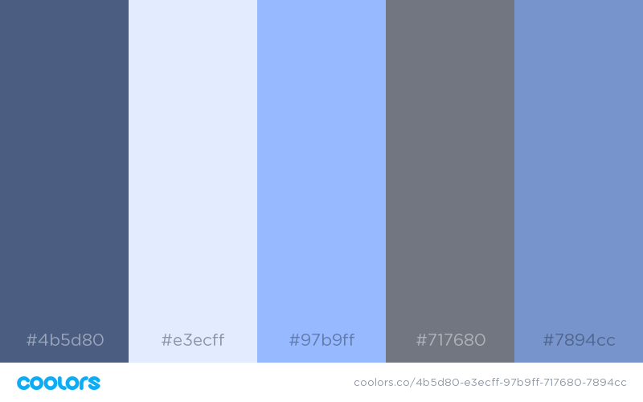

Typography

Site header #4b5d80 Helvetica Bold

Navigation #97b9ff Open Sans

Selected #97b9ff Open Sans

Unselected #7894cc Open Sans

h1 #4b5d80 Spectral SC

h2 #4b5d80 Spectral SC

h3 #4b5d80 Spectral SC

p #000 Poppins

Site Map